Q1
Data given
The patty is circular with a diameter of 6cm and height of 0.5cm
Assumption
The cells assumes a circular shape
The cells diameter is 0.05mm
And its height ranges from1-100micromters
The number of cells = the volume of patty dived by the volume of one cell
The volume of one cell is estimated as $πh\frac{D2}{4}$
Using h with range from 1 – 100micrmeters
We have estimated ne cell volume to be between 1.963495 x 10⁻⁴mm³ to 1.963495 x 10⁻²mm³
The volume of the circular patty is 14137.166 mm³
Therefore, the numbers of cell is between 80 million to 8 billion cells.
Q2

- the cell counts for each of the 16 squares were 57, 67 56 62, the average cell count is :
- (57 + 67 + 56 +62) ÷ 4 = 60.5
- 60.5x 10,000 (10⁴) = 605,000
- 605,000 x 5 = 3,025,000 live cells/mL in original cell suspension
- The number of cells seeding per day would be 21 million divide by 4
We get 5.24 million cells per day
In four days we will have 21 million cells and the density total density of cells are 40 million in the total
So the reaming space is 19 million cells(40-19)million
Therefore the numbers of days will be 19 million divide
The number of days is 19 divide by 5.25
We will have 3.6 days

Q3
1. Breaking the extracellular matrix that holds the cells together is the first step in isolating cells of the same kind from a tissue having a diversity of cell types.
Several approaches are used to separate different cell types from a mixed cell culture.
These methodologies will be addressed more below in connection to the separation of organelles and macromolecules, for which they were originally devised.
The distinct binding properties of antibodies are critical in improving this final strategy.
Antibodies that attach only to the surface of one cell type in a tissue can be coupled to diverse matrices, such as collagen, polysaccharide beads, or plastic, to create an affinity surface to which only the antibodies' designated cells can adhere.

2. A. detecting metabolic rate - The observation of metabolic activity in a cell population can signify the condition of cell growth. Lactate dehydrogenase activity increases during cell development, causing tetrazolium salts or Alamar Blue to gradually diminish in the metabolically active cell environment. As a result, a formazan dye is produced, which may influence the colour of the growth medium. To determine cell growth and metabolic activity, the absorbance of a dye-containing solution can be measured using a low-profile or high-profile spectrophotometer and a microplate reader.

B. cell proliferation market - Some antigens are present only in proliferating cells and are not detected in non-proliferating cells. Cell growth can also be detected using specific monoclonal antibodies. The Ki-67 antibody, for example, recognises the same-named protein in human cells and is generated throughout the S-, G2-, and M-phases of the cell cycle, but not during the G0- and G1 phases (non-proliferative phases). Cell growth may be monitored using antibodies against the Ki-67 protein. Due to the necessity for tissue sectioning, this method does not allow for high-throughput analysis.

C. ATP concentartion - Because the content of ATP in cells is strongly controlled, measuring ATP can also provide information about cell development. Dead or near-dead cells have almost little ATP, and the amount of ATP measured in cell lysates or extracts has a strong linear connection with cell population. Detecting ATP with bioluminescent luciferase and its substrate, luciferin, can produce extremely sensitive results. If ATP is present, the luciferase will emit light, the intensity of which is proportional to the concentration of ATP. Luminometers and microplate readers capable of sensing luminescence signals can be used as basic detection techniques.

D. DNA production - DNA synthesis assays are the most exact and consistent method of measuring cell development in the laboratory.Typically, radiolabeled 3H-thymine is incubated with cells for several hours or overnight. The newly multiplying DNA cells will incorporate the radiolabels after elution and may be recognised using a scintillation counter. The advantages include the fact that thymidine (3H-TdR) is accurate and trustworthy, as well as sensitive and repeatable. Scintillation counters, on the other hand, are costly and time-consuming to operate. Another apparent disadvantage is the difficulty and hazard of using and handling radioactive materials.

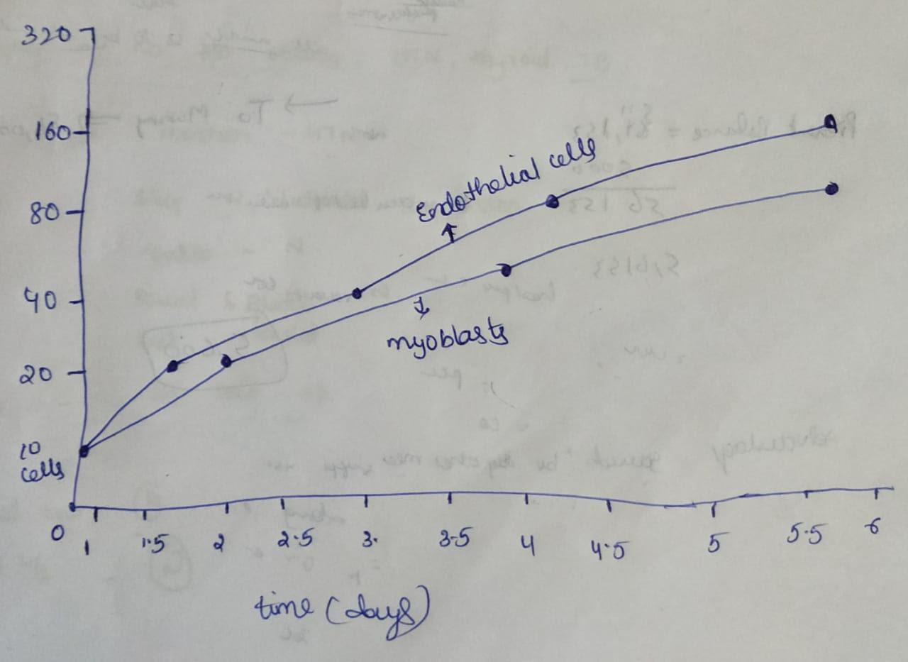
4. Systematic error may be decreased by regularly calibrating equipment, using controls in research, warming up instruments before taking measurements, and comparing results to standards. While increasing sample size and averaging data can minimise random errors, adjusting for systematic inaccuracy is more challenging.
Measurement Error Reduction Techniques
All measurements should be double-checked to ensure accuracy.
Make sure your formulas are right.
Ensure that all observers and measurement takers have received adequate training.
Use the most exact tool available to do the measurement.
Measurements should be taken in a controlled setting.
Q4
  - Explain the physical meaning of the 3 terms identified below (4 pts):

- $\frac{∂c_{O2}}{∂t}$ Diffusivity and the 2nd derivative (or curvature) of concentration, measured as [cm-3 cm-2] or [cm-5], are directly proportional to the accumulation, calculated as dC/dt [cm-3 s-1]. For example, a positive concentration gradient on one side leads to a positive concentration gradient on the other side, resulting in more flux being driven into the front end than out of it, or when accumulation is favorable, a positive concentration gradient on one side leads to a positive concentration gradient on the other side.

- $D\left(\frac{∂^{2}c_{O2}}{∂x^{2}}+ \frac{∂^{2}c_{O2}}{∂r^{2}}+ \frac{2}{r}\frac{{∂c}_{O2}}{∂r}\right)$ While C [mol.m3] represents the molecular oxygen concentration (mol.m3) in the gel, R [mol O2 consumedm3s1s1] represents the molecular oxygen diffusion coefficient and the cellular oxygen consumption rate per unit volume of the construct (which is considered to be homogeneously packed with cells). Over a short period of time, we were not able to account for cell growth or death, which might have affected our results (which lasted less than 1 hour). For this reason, it was difficult to draw conclusions from the results of the studies. With Michaelis-Menten kinetics (Equation 1) (Matti et al., 2014), Vmax was found by substituting Vmax = sOCR for Vmax = sOCR and solely considering oxygen concentration fluctuations in time and height.

- -r_{O2 ---} sOCR (molcell1s1) is the maximum rate of oxygen consumption per cell expressed in Equation (2). (molcell1 s1). To put it another way, the R(z,t) = Vmax = Cell SCOR Saturation occurs when oxygen concentrations exceed Km (i.e. when C(z, t) > Km), which results in the highest rate of reaction (z, t). An oxygen consumption rate (OCR) of [mol cell1s1] has been reported in many research on oxygen use, which may be represented as the volumetric average of local oxygen consumption rates (depending on time and space) within the cell volume V. OCR (mol cell1 s1), a time-dependent statistic that may be equated to volume, is the most often reported oxygen consumption rate (OCR) in most research.

  - For the system described, we consider the one-dimensional situation by ignoring the changes in C_{O2} in the r direction. Discuss why this might be a valid assumption and write the resulting equation. (4 pts)
The quantity of oxygen that cells in the body are exposed to has an effect on them. Tissue engineering is dependent on the capacity to monitor oxygen levels in an organism's culture medium and to determine the kinetics of cell oxygen consumption. Due to a lack of exact instruments for detecting oxygen concentration in tissues across time and space, determining the average cellular consumption rate (OCR) in three-dimensional structures, also known as the oxygen consumption rate, is challenging (OCR). As a consequence of our findings, the OCR is not consistent for a particular cell type or organ or organ design. The oxygen diffusion coefficient of a tissue and the magnitude of the Michaelis-Menten constant are both proportional to the volume of cells present in the tissue or scaffold at a certain construction dimension. As a result, the literature should not assume constant consumption parameters. OCR is an essential component of tissue oxygenation, and our research provides a foundation for the future interpretation, improvement of analytical methodologies, and management of 3D cell culture systems. When utilized in conjunction with any 3D model seeded with any cell type, the OCR may be determined as a function of cell density. Additionally, if the cell density at the time points of interest is known precisely, the OCR at discrete time points may be calculated.

The boundary conditions are given as:

$$x=Z, \frac{∂C}{∂x}=0$$

$$x=0, C\left(0,r\right)=C_{medium}= 178.5 nmol/mL$$

  - Demonstrate that for the steady state condition, the concentration, C_{O2}, varies according to the equation: (Show all steps. State assumptions) (6 pts)

$$C_{O2}= \frac{r_{O2}x}{D}\left(\frac{x}{2}-Z\right)+178.5$$
This implies emphasizing the local oxygen concentration (C), which has an effect on both spatial dimensions (x and y, height z) and time (t) (x, y, z, t). The Michaelis-Menten constant is a critical factor in determining the rate of volumetric oxygen consumption (equal to the oxygen concentration at which consumption decreases to half of its maximum and expressed in [molm3]). Vmax and Km are assumed to be constants for the system. The rate of cellular oxygen consumption is only "adaptive" in the sense that it is reliant on the oxygen concentration of the surrounding environment.

Each cell in a monolayer has the same OCR at any one moment because each cell detects the same oxygen concentration from the oxygen source (i.e., C is the same for all x and y, while z is constant). As a consequence, cells located near the medium or a capillary use oxygen at a faster rate, whereas cells located farther away consume less oxygen. Because 3D cells use oxygen at a slower pace than 2D cells, they need less oxygen per cell.

Changes in intrinsic consumption constants such as Km, cell density, and cell type all affect the oxygen consumption properties of cells. We utilized a combination of experimental and computational methods to determine the influence of cell density on oxygen consumption in three-dimensional structures. The focus of this work was on three-dimensional hydrogels filled with varying densities of hepatocytes. Rather than being treated as constants in conventional mathematical models of oxygen transport, experimental oxygen measurements were utilized to calculate the diffusion coefficient, Vmax, and the maximum oxygen consumption, Km, which are often treated as variables in such models.

  - Sketch the graph of C_{O2} vs. x (for x ranging from 0 to Z) (6 pts)

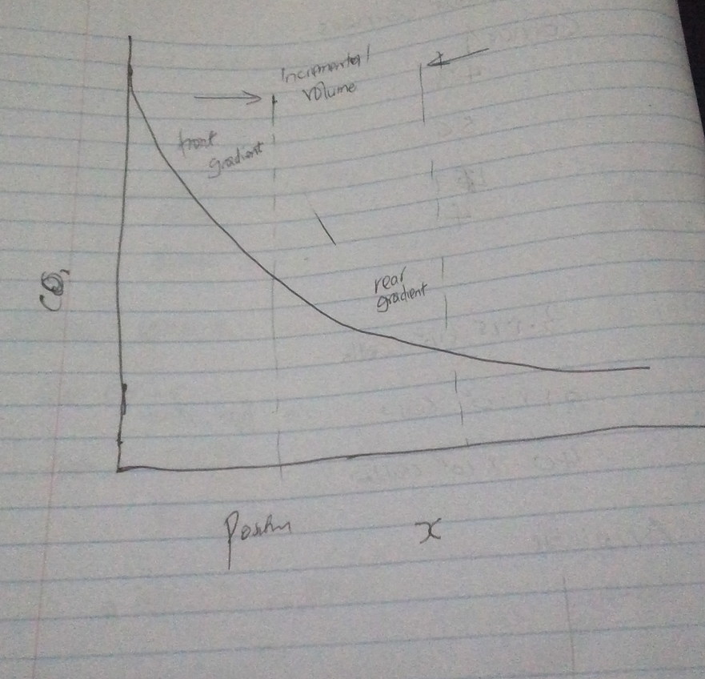

  - The viability of skeletal myoblasts becomes compromised at partial pressures of O₂ below 38 mmHg. In the system, the cells in the bottom 50% of the scaffold are oxygen deprived. Based on this, determine the flux of O₂ through the scaffold at the point where O₂ becomes limiting. (4 pts)

D (diffusivity of O₂ through medium) = 2 x 10⁻⁵ cm²/s
K (solubility of oxygen in medium) = 1.19 nmol/mL/mmHg
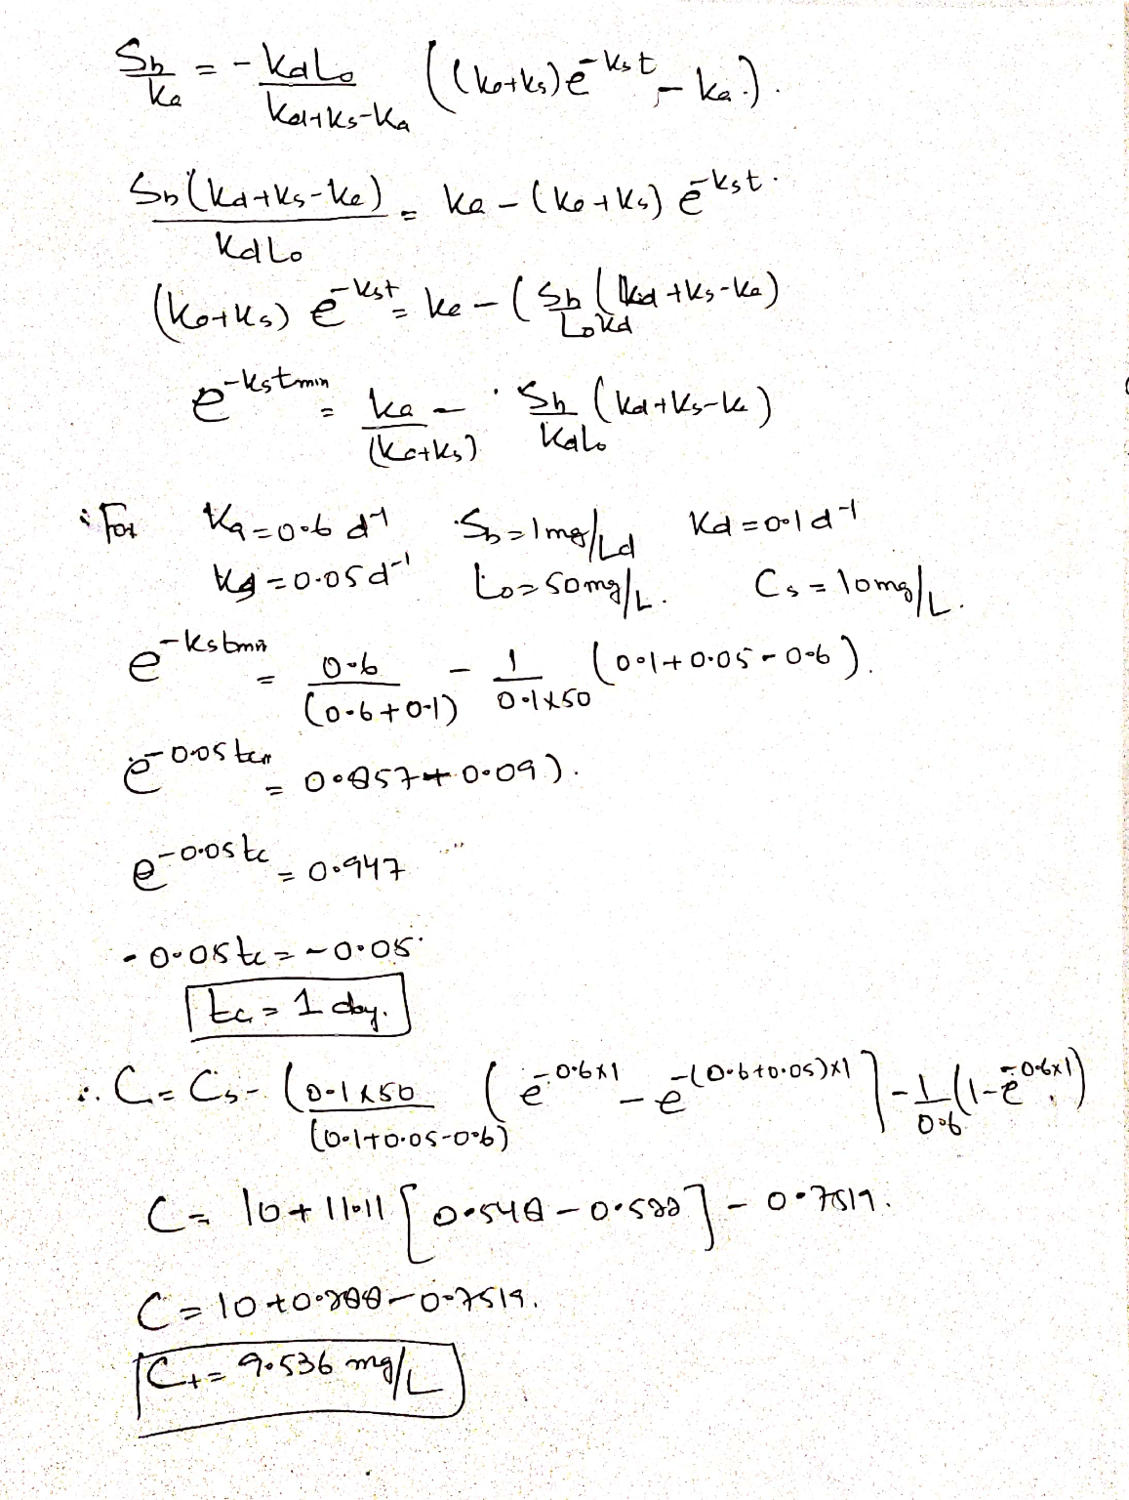

Assume that the flux was constant throughout the entire construct. Consider your response to Question 1, what would be the specific oxygen uptake for skeletal myoblasts in your ready-to-eat engineered muscle? (3 pts)

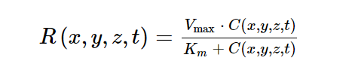
This equation has been demonstrated to produce the same OCR for each cell placed on the monolayer since they are all situated at exactly the same distance from oxygen and so perceive exactly the same concentration of oxygen at any given moment (i.e., C is the same for all x and y, while z is constant). Cells close to the medium or a capillary feel large amounts of oxygen, and therefore consume at a faster pace, whereas cells further away perceive lower levels and consume at a lesser rate. Compared to 2D, 3D cells use less oxygen on average per cell.

